CSE 595 Independent Study

Graph Theory

Week 7

California State University - San Bernardino

Richard Vargas

Supervisor – Dr Owen Murphy

Chapter 4 Problem 1 (Connectivity and Edge-Connectivity)



Connectivity, denoted by $κ(G)$, is defined by Chartrand [1] as

*Minimum cardinality vertex-cut of a graph $G$*

If we let $G$ be the graph which is a complete $k$-partite graph, with order $n$. It can be assumed that the largest partite set may contain $n_{k}$ vertices, then

$$κ\left(G\right)=λ\left(G\right)=δ(G)$$

And therefore,

$$n=n-n_{k}∎$$

Chapter 4 Problem 5 (Connectivity and Edge-Connectivity)



Looking at the previous chapter, Theorem 3.20 in Chartrand [1] can be applied which states,

*Let $T$ be a tree of order $c$. If $G$ is a graph for which $δ\left(G\right)≥c-1$, then $G$ contains a subgraph that is isomorphic to $T$.*

We can look at the following fact,

$$k≤κ\left(G\right)≤δ(G)$$

We may apply Theorem 3.20, and by this theorem we have proven that there exists a subgraph $G$ isomorphic to $T$.

Chapter 4 Problem 9 (Connectivity and Edge-Connectivity)



Looking at the simplest case of a graph $P_{3}$.

Thus in $P_{3}$,

$$a=1, b=1, c=1$$

This holds for the inequality given in the problem.

*Reasoning*

Removing the middle node in $P_{3}$ we end up with 2 $K_{1}$, which is a disconnected graph and satisfies $κ(P_{3})$.

Deletion of any edge in $P_{3}$ will create a disconnected graph of $K_{1}P_{2}$, satisfying $λ\left(P_{3}\right)$.

Minimum degree of the graph is obviously 1, therefore we have proved that this graph satisfies the conditions $∎$.

Chapter 5 Problem 1 (The Königsberg Bridge Problem)

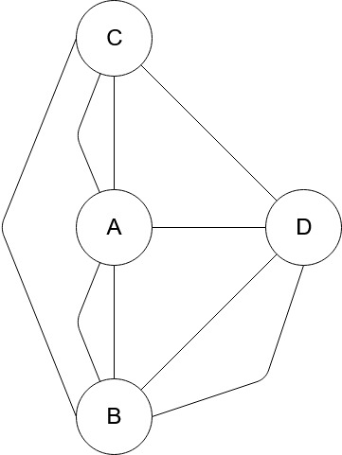

The original Königsberg bridge problem was impossible to have a path the crossed all bridges once without revisiting a bridge. The problem was impossible because the length of the sequence could only be $n+1$ where n is the number of bridges (edges). If a sequence of letters represented the path that must be followed that sequence had a minimum length of 9.

The problem presented above states that there are two extra bridges, which are depicted to the left. If we represent our path with a sequence of letters representing the nodes, then we would need the following letters to be occur in the sequence with the corresponding amount of times

$$A: 3$$

$$B:3$$

$$C:2$$

$$D:2$$

The summation of the number of occurrences of each node in the sequence must be 10, which is equal to $n+1$ in this new case. $∎$

Chapter 5 Problem 3 (The Königsberg Bridge Problem)  


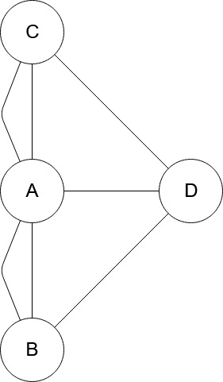 Yes, this would be possible. In the original Königsberg bridge problem, there are 7 bridges, however we wish to cross these bridges a twice each, so we must cross 14 bridges total. This means that every node with an odd edge can visit any of its adjacent nodes and return.

If we have the following sequence $ADCDBDA$, we have eliminated the edges $AD, CD, BD$ as well as node $D$. We can now add to our sequence $CACA$ and $BABA$. Our final sequence is then

$$ADCDBDACACABABA$$

Each node is visited the corresponding number of times,

$$A:6$$

$$B:3$$

$$C:3$$

$$D:3$$

The summation of this sequence is $15$, which is $n+1$ the number of edges, where $n$ twice the amount of bridges. $∎$

Works cited

“Trees.” *Graphs & Digraphs*, by Gary Chartrand et al., CRC Press, 2016, pp. 95–116.